Azure Data Factory
- Linked Service
Created Source, Target, and Key Vault (for credential fetching)
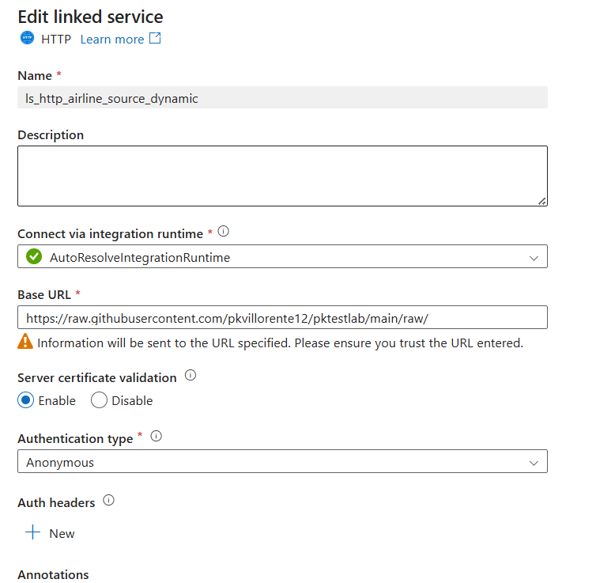

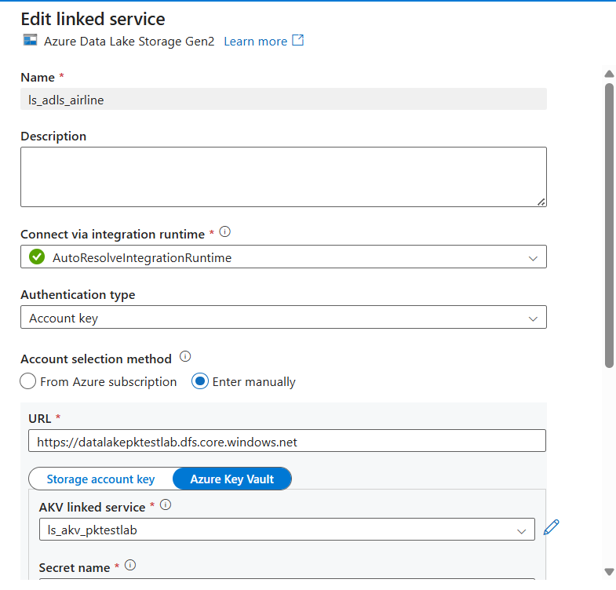

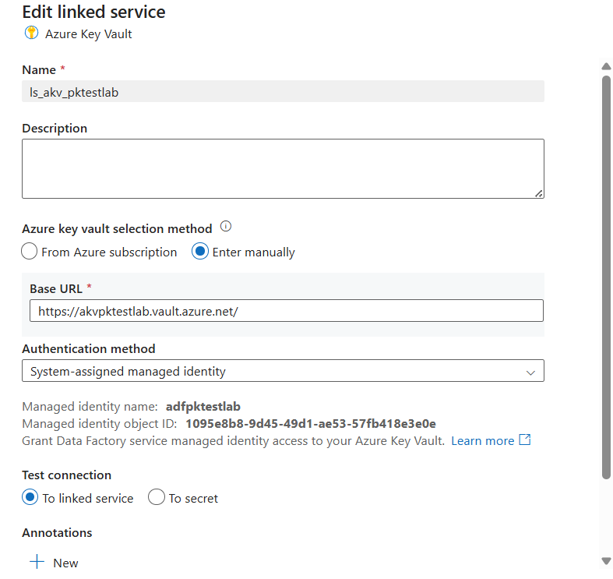

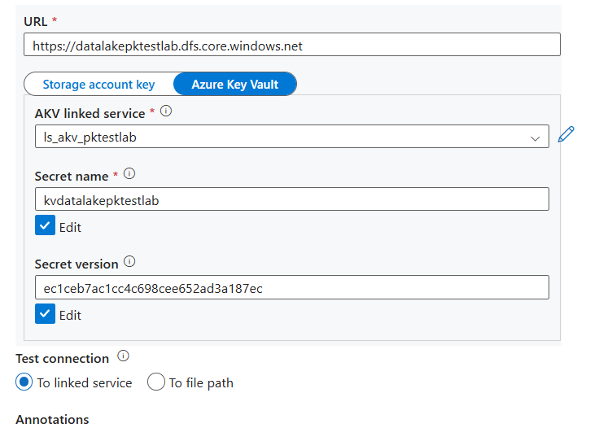

- Created Source and Target Datasets
@dataset().filename is used to get the value being passed in the pipeline.
This can be enhanced by making the value fetched automatically by the pipeline then pass the value to this pipeline to process the file.

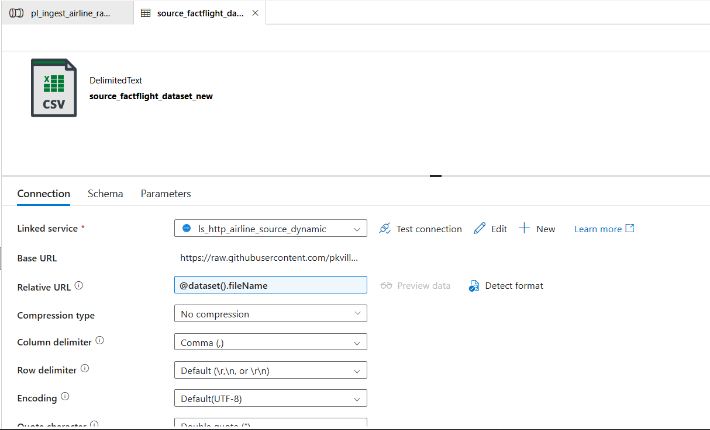

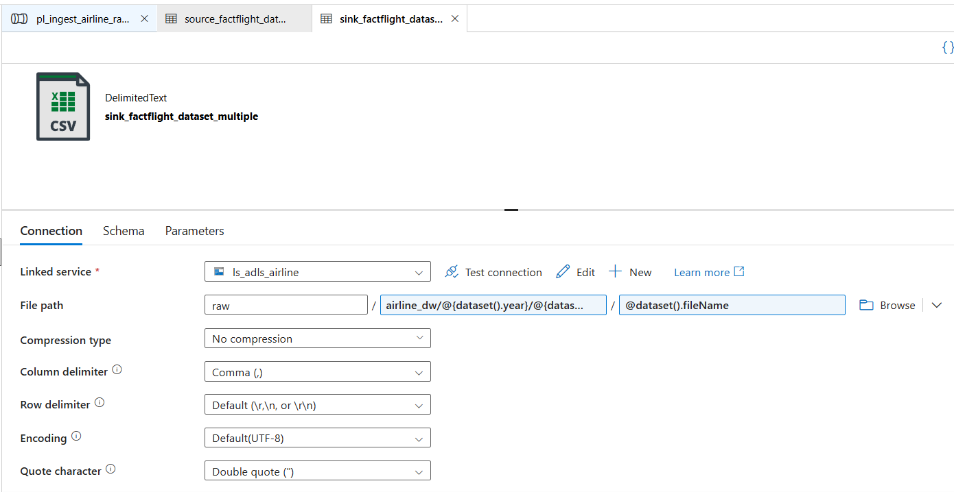

- Create Pipeline Activity
Used the foreach pipeline to loop thru an array which will be passed on by the Debug Value
Inside the activity is the copy activity that gets from Source and Sink to Target according to the filename year month.

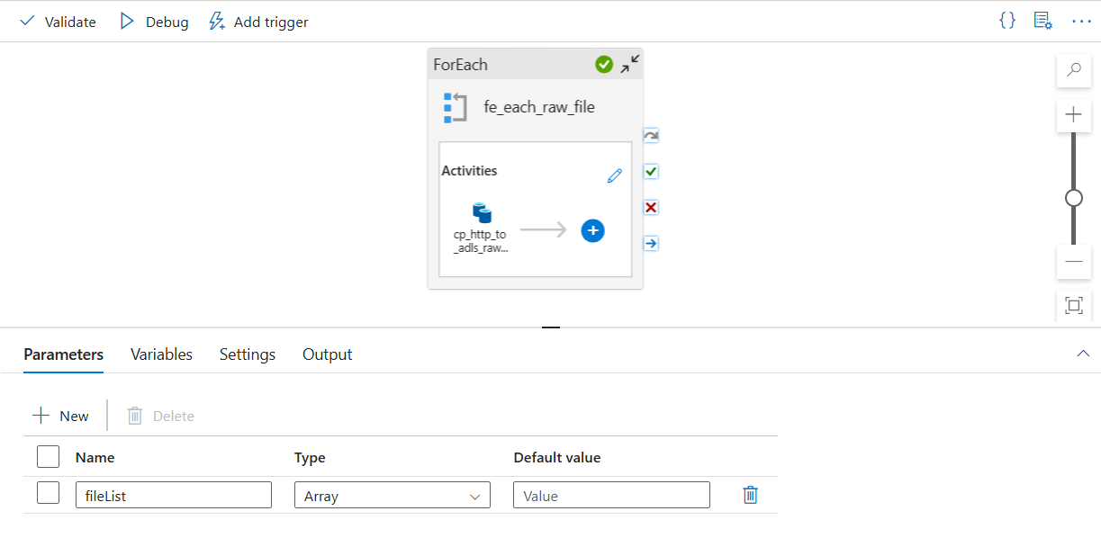

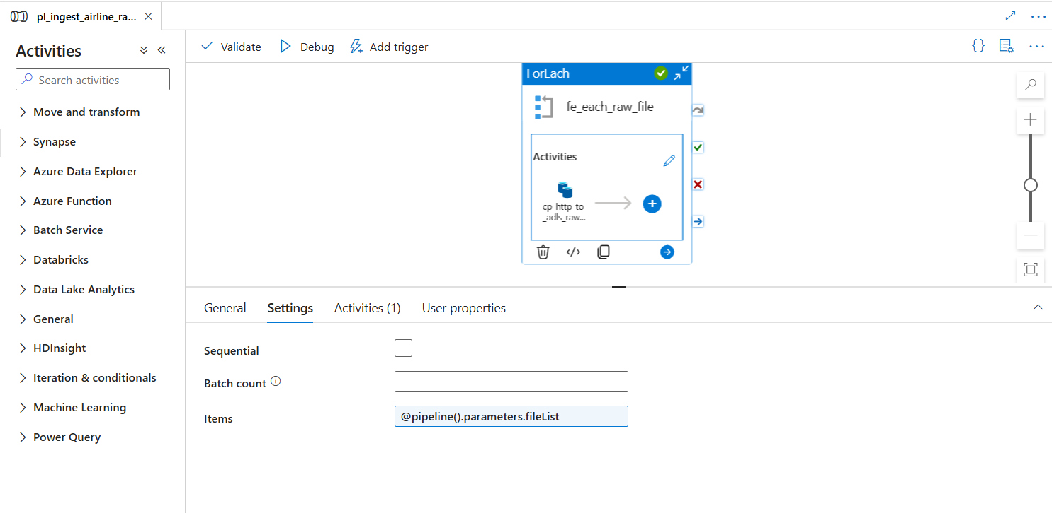

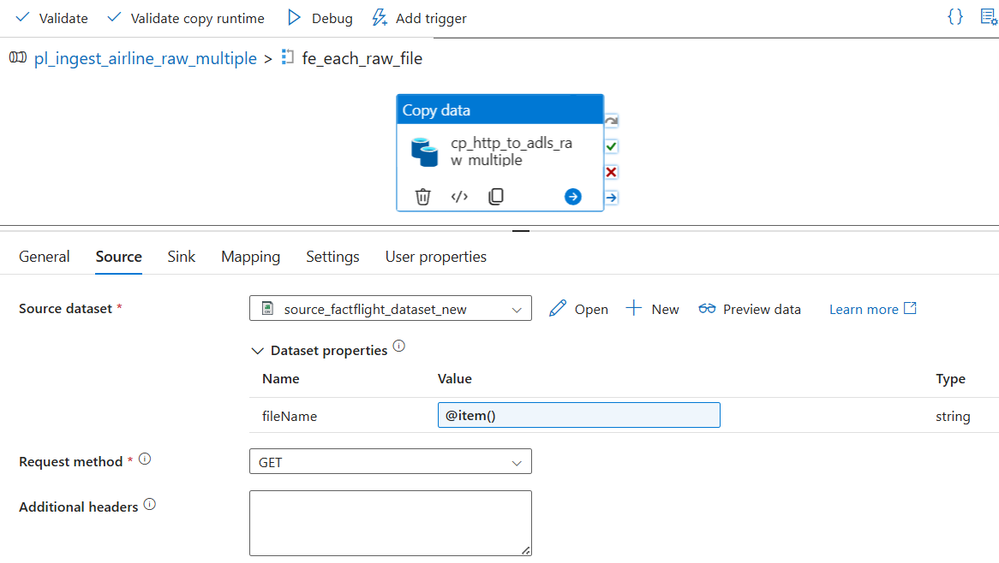
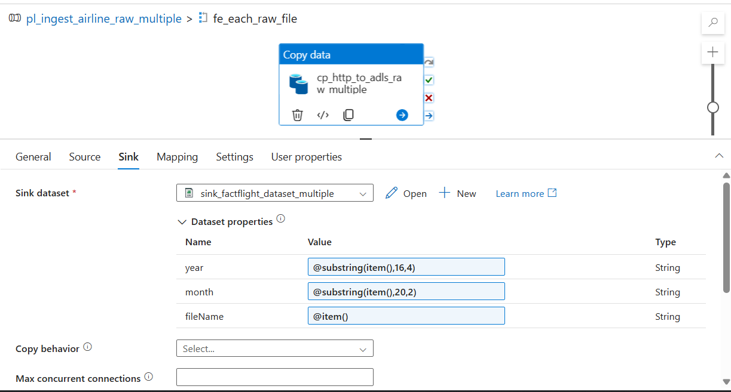
year: @substring(item(),16,4)
month: @substring(item(),20,4)
fileName: @item
Pipeline Value to be passed on:
[
"FactFlights_raw_202401.csv",
"FactFlights_raw_202402.csv",
"FactFlights_raw_202403.csv"
]

